The Complexity of Physical Mapping

with Strict Chimerism
Stephan Weis and Rudiger Reischuk
Abstract
We analyze the algorithmic complexity of physical mapping by hybridization in situation of restricted forms of chimeric errors.
- Introduction
Physical mapping
Fragment
Clone library
Probes
Fingerprint
Chimeric fragment
- Basic Definition and Notation
Let M be a binary matrix with r rows and c columns.
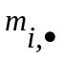: i-th row in M ; 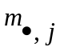: j-th row in M
|||| : the number of ‘1’s in ; |||| : the number of ‘1’s in
Definition 1: clone library
Fragments
fingerprint
probes.
Definition 2: k-chimeric
.strict k-chimeric
.isolated framents of the chimeric row.
.M obeys the (strict) k-consecutive ones order
Definition 3: potentially k-chimeric
.potentially chimeric
Lamma 1: It is NP-complete to decide whether a specific row of a matrix is potentially k-chimeric.
Definition 4: (strict) k-consecutive ones property 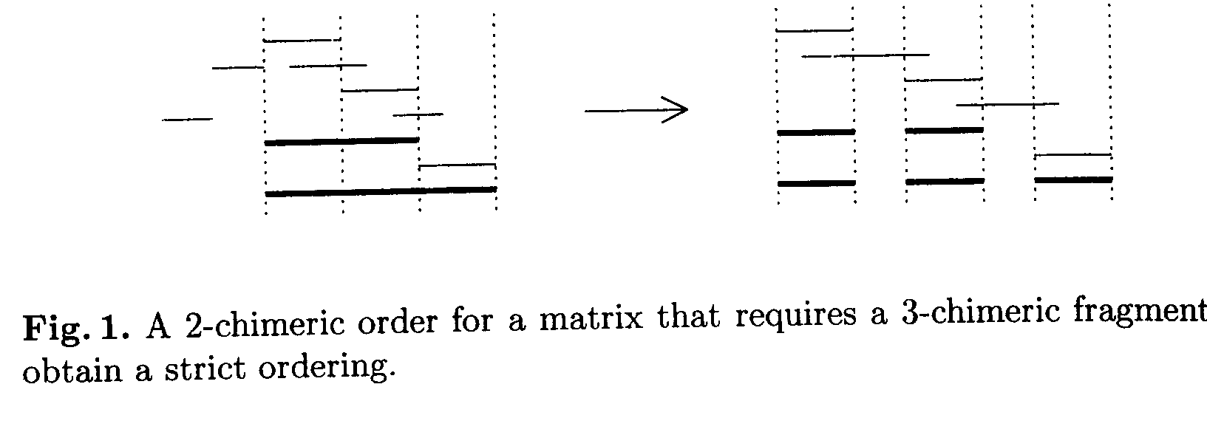
Definition 5: the problem (u|l) –Physical-Mapping with strict k-chimeric errors
The optimization version of (u|l) –Physical-Mapping with strict k-chimeric errors
Definition 6:The overlap graph of hybridzation matrix M is given by G=(P,E) with E:={{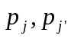}|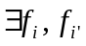 with 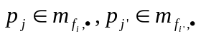 and 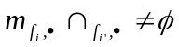}. Let M be a matrix and M’ the submatrix that contains exactly those rows of M that are potentially chimeric. Let G=(P,E) be the overlap graph of M’ and G₁=( P_{1,} E₁),…., G_{z}=( P_{z,} E_{z}) its connected component. The vertex sets Px are called islands of M.
- Two Simple Case
Thereom 1 Let M be an instance for (2|-)-PHYSICAL-MAPPING with strict 2-chimeric errors. If M has the 2-consecutive ones property then it has 1-consecutive ones property,too.
- The Complexity of the Decision Problem
Thereom 2 (11|5)-PHYSICAL-MAPPING with strict 2-chimeric errors is NP-complete.

Created by : Yi-Ying Chen
Date : Nov. 28,2000

